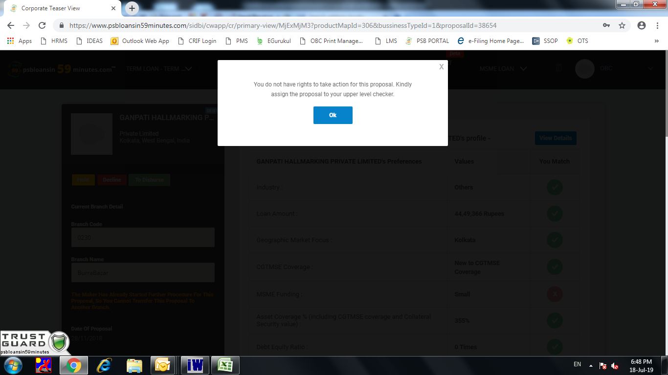

**Proposal no- CW-ATL-11986**

Proposal no- CW-AWCTL-10221-295166

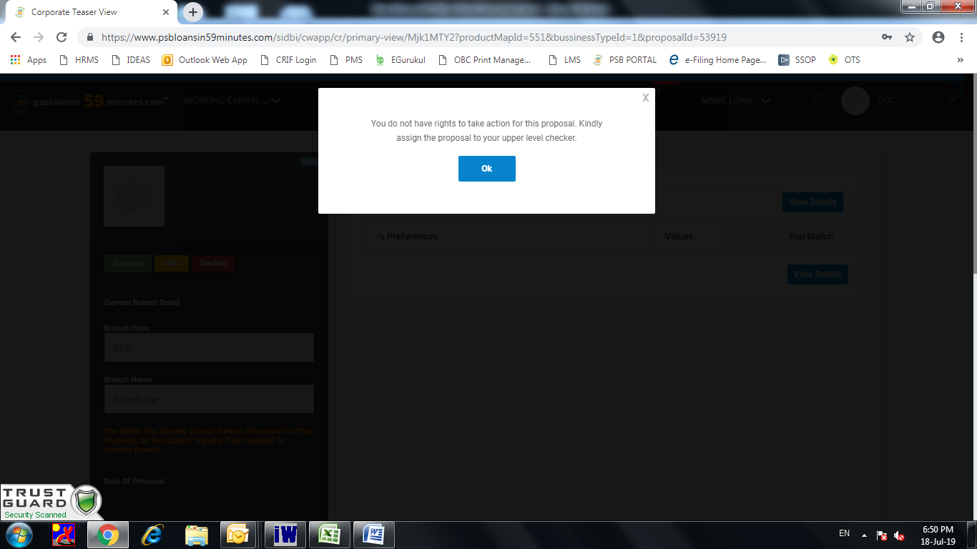

Proposal No - CW-AWC-59274-376069

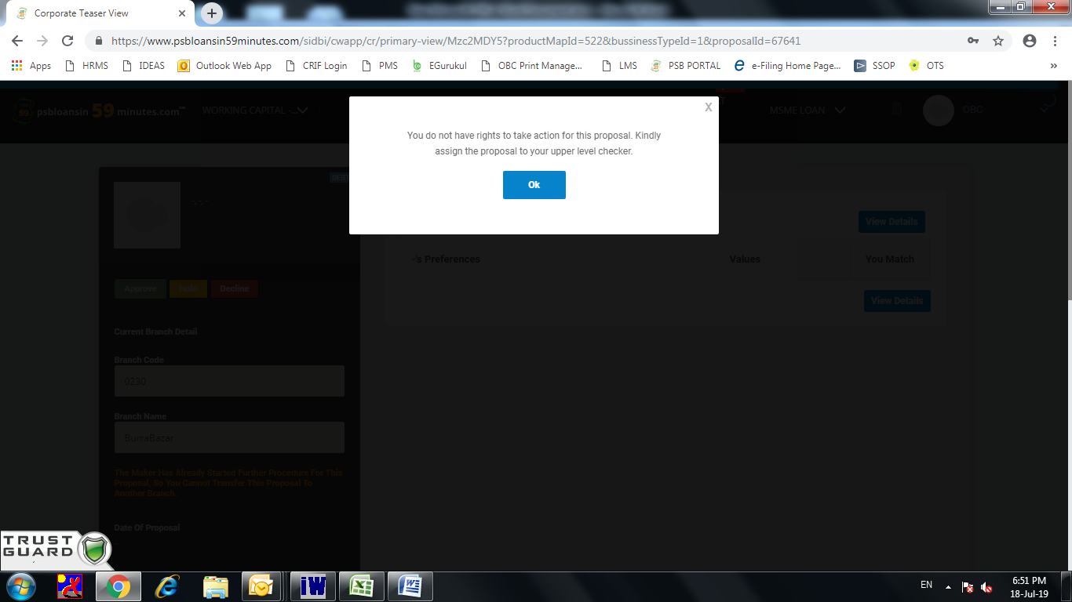

Proposal No- CW-AWC-66448-426138

